90

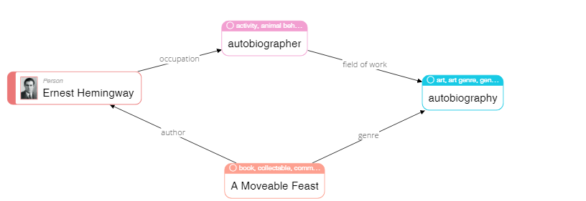

|  |
| --- |
| **Please describe shortly what you see on this diagram? Pay attention only to that information that is understandable or has sense for you.** |
| I see that Ernest Hemingway is an author of ‘A Moveable Feast’ and this book has autobiography as genre. In addition, it is biography of Ernest Hemingway. |

68

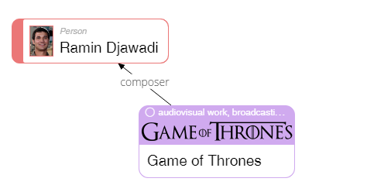

|  |
| --- |
| **Please describe shortly what you see on this diagram? Pay attention only to that information that is understandable or has sense for you.** |
| Ramin Djawadi is a composer, who wrote music for the TV series, which called Game of Thrones. |

23

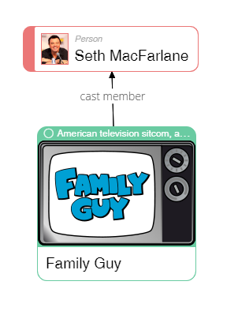

|  |
| --- |
| **Please describe shortly what you see on this diagram? Pay attention only to that information that is understandable or has sense for you.** |
| Seth MacFarlane dub some hero from the cartoon, which called ‘Family Guy’. |

50

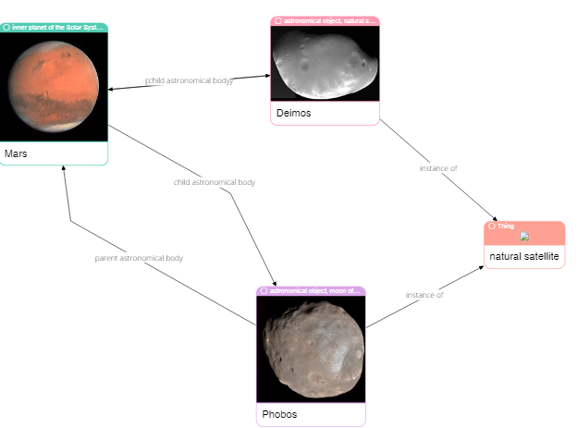

|  |
| --- |
| **Please describe shortly what you see on this diagram? Pay attention only to that information that is understandable or has sense for you.** |
| Mars has two satellites. Theirs names are Deimos and Phobos. |

62

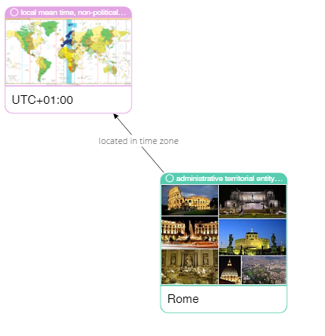

|  |
| --- |
| **Please describe shortly what you see on this diagram? Pay attention only to that information that is understandable or has sense for you.** |
| The Rome’s time zone is UTC+01:00. |

75

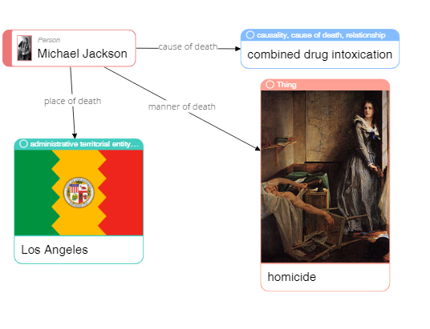

|  |
| --- |
| **Please describe shortly what you see on this diagram? Pay attention only to that information that is understandable or has sense for you.** |
| Michael Jackson was killed in Los Angeles by drugs. |

79

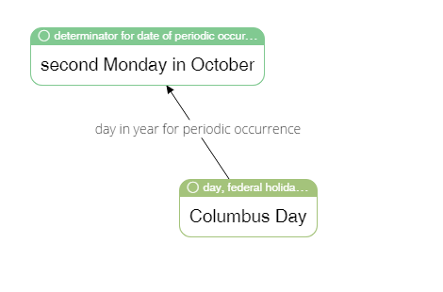

|  |
| --- |
| **Please describe shortly what you see on this diagram? Pay attention only to that information that is understandable or has sense for you.** |
| Columbus Day is in second Monday of October. |

65



|  |
| --- |
| **Please describe shortly what you see on this diagram? Pay attention only to that information that is understandable or has sense for you.** |
| Ole Kirk Christiansen was carpenter and joiner then he invented Lego, and became entrepreneur. |

4

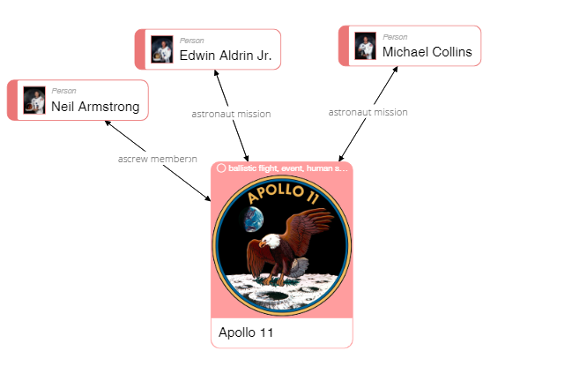

|  |
| --- |
| **Please describe shortly what you see on this diagram? Pay attention only to that information that is understandable or has sense for you.** |
| Neil Armstrong, Edwin Aldrin Jr. and Michael Collins were in team of Apollo 11. |

40

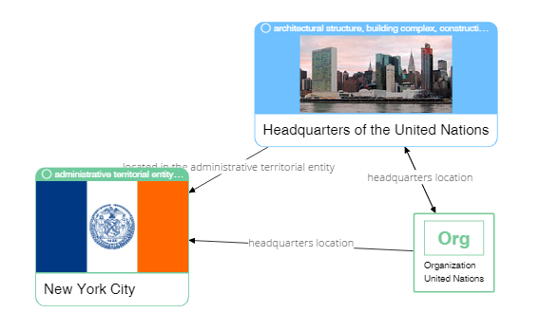

|  |
| --- |
| **Please describe shortly what you see on this diagram? Pay attention only to that information that is understandable or has sense for you.** |
| Headquarters of United Nation Organization is in New York City. |

37



|  |
| --- |
| **Please describe shortly what you see on this diagram? Pay attention only to that information that is understandable or has sense for you.** |
| The headquarters of the stadium, which called Estaio do Dragao is located in Porto. The maximum capacity of the stadium is 50431. |